**Exercise 2: TDD Feature Implementation**

### **Objective:** Develop a simple calculator that performs addition, subtraction, multiplication, and division by writing tests first.

## **Step-by-Step Instructions**

1. **Define Your Feature**
   1. **Decide on the Functionality:**
      1. You will implement functions for adding, subtracting, multiplying, and dividing two numbers.
2. **Write Your Test Cases First**
   1. Open the file test_main.py that you created in Exercise 1.
   2. Add a comment to describe your test:

|  |
| --- |
| #Test for calculator functions |

* 1. Write a Test for Addition:

|  |
| --- |
| **def test_add():  assert main.add(1, 2) == 3  assert main.add(0, 0) == 0** |

* 1. Type the following code (you can let Copilot suggest improvements):
  2. **Repeat for Other Operations:**

Type comments such as:

|  |
| --- |
| #TODO: Write tests for subtract, multiply, and divide functions |

*Allow Copilot to suggest complete tests if available.*

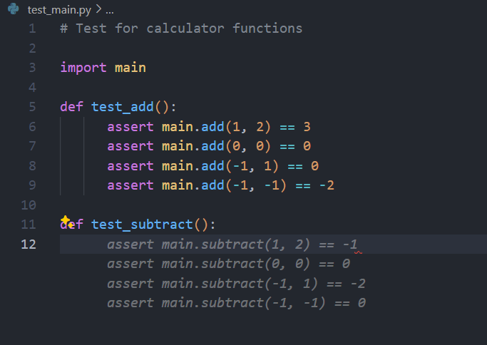

* 1. Save the test file.

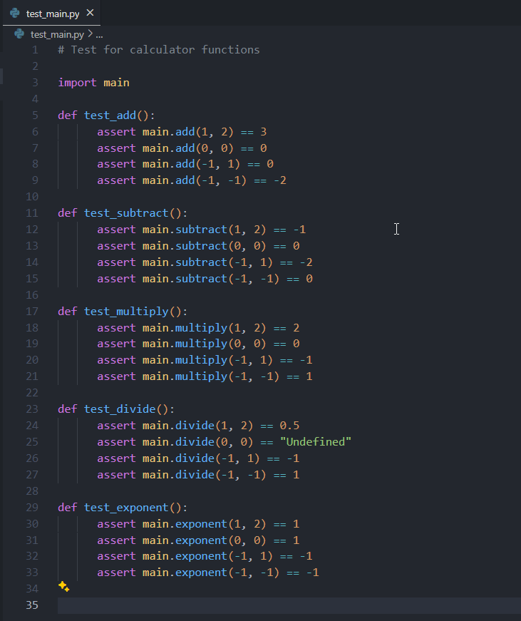

1. **Implement the Feature in main.py**
   1. Open main.py.
   2. Write the Addition Function:  
      Begin with a comment:

|  |
| --- |
| # Function to add two numbers |

* 1. Then type the function signature:

|  |
| --- |
| def add(a, b):  return a + b |

GitHub Copilot may suggest further details; accept or modify as needed.

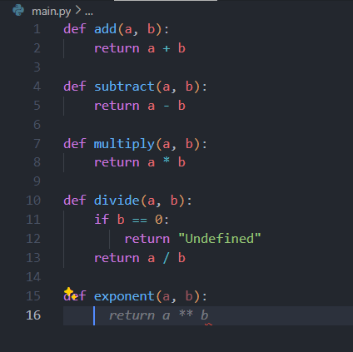

* 1. **Implement the Other Functions:**
     1. Similarly add functions for subtraction, multiplication, and division:

|  |
| --- |
| def subtract(a, b):  return a - b  def multiply(a, b):  return a * b  def divide(a, b):  if b == 0:  raise ValueError("Cannot divide by zero")  return a / b |

* 1. Save the file.

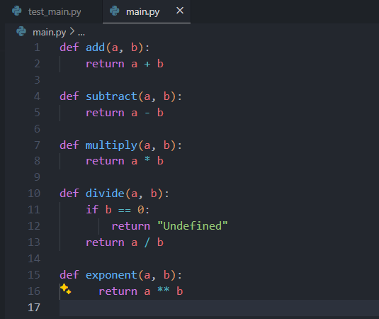

1. **Run Your Tests**
   1. Open the terminal.
   2. Run your tests using a tool such as pytest or Python’s built-in unittest. For example:

|  |
| --- |
| pytest |

* 1. Ensure all tests pass. If a test fails, review the suggestions from Copilot and adjust your code accordingly.

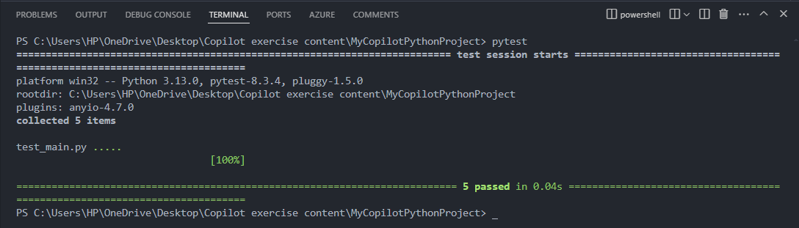

1. **Commit Your Changes**
   1. In the terminal, run:

|  |
| --- |
| git add . git commit -m "Implemented calculator functions using TDD in Python" |

Voila!! We have successfully completed this exercise.